English Version

🚀Top semiconductor companies are hiring foreign STEM talents in Taiwan!

ELAN, Micron, SPIL, VIS & WinWay will be at '2025 Semiconductor Global Talent Connect', conducting talks & 15-min speed interviews, on Saturday, Oct 4th.

Meet and connect with them at:
🗓️ Oct 4 (Sat) 13:00 – 17:00
📍 Taipei WTC Hall 1, 2F, Room A3
👩‍💻 Register & submit your resume before September 21st to apply for speed interview!

This event is perfect for:
◾️ Tech job seekers exploring career transitions
◾️ Fresh graduates from a STEM background
◾️ Professionals & honestly whoever eager to learn about semicon trends

Sign up for the hiring event now 👉 https://global.cake.me/nf97lb
Spots are limited – don’t miss it!

| Official social media posts: Facebook | Linkedin | Instagram

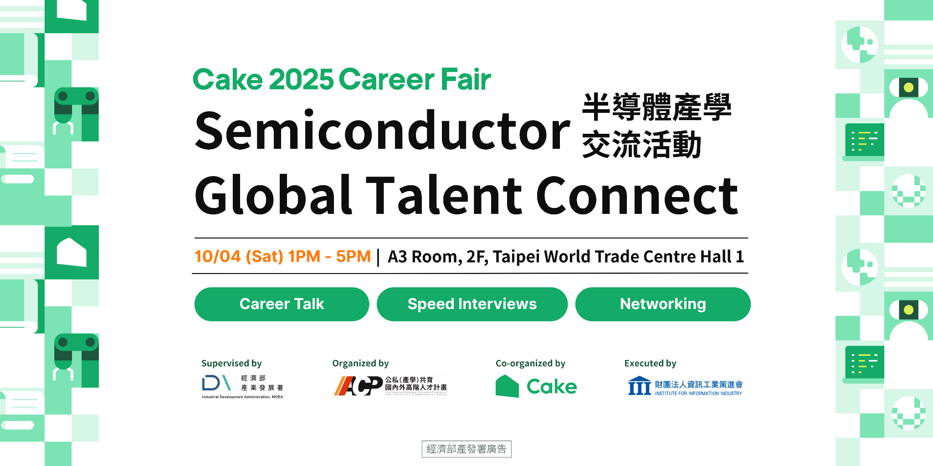

>>>>> Download image HERE <<<<<

中文版

\ 🚀 ELAN、Micron、SPIL、VIS 與 WinWay 正在尋找像您的在臺外籍科技人才！/

10 月 4 日下午，五家精選公司的招募團隊將在「2025 半導體國際人才交流會」進行論壇及一對一快速面談。這場活動是您在台灣升級半導體職涯的最佳舞台 —— 全場免費！🌏✨

活動時間與地點

🗓️ 10月4日（週六） 13:00 – 17:00
📍 台北世貿一館二樓 A3會議室
👩‍💻 9/21 前上傳履歷報名與一對一人資快速面談！

如果您是...

◾️ 想探索職涯轉換的科技求職者
◾️ 理工科學背景的新鮮人
◾️ 想了解半導體最新趨勢的專業人士及任何人

立即免費報名參加！👉 https://global.cake.me/nf97lb
名額有限，千萬別錯過！

官方貼文：Facebook | Linkedin | Instagram

>>>>> 圖片下載 <<<<<

